November 7th, 2010
Hi,
I, along with two other people, received an interesting e-mail from Air NZ the other day. It was telling us to collect a container from their depot! I replied saying it was not mine and also asking them how they got my e-mail address which is different from the one they already have. Next day I got another mail saying that a mistake had been made.
Cooler weather in HK at last, which is good. Water temperatures are also lower but not bad for swimming. I had three good swims this past week, two of them being 3 km each. I did not intend to swim that far but it felt good and quite easy so I just kept going. But why does it take the whole season to get to the stage where the swims feel good? The swims were probably also the fastest for the season taking about 24 min for a km.
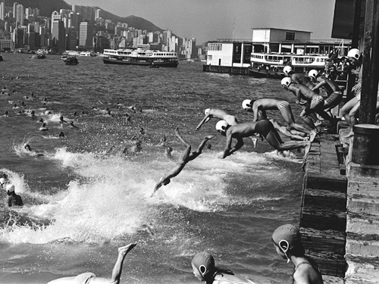
A few other interesting HK news items. The government is encouraging people to get flu jabs before the winter flu season arrives. One enterprising district councillor decided to give out a free bag of rice to each elderly person that got a jab (also free). Quite a lot of people took up the offer. But there are reports of people getting multiple flu jabs in order to get more bags of rice!! Apparently this is not advisable. Also other interesting items in today's SCMP. On the front page is a photo of a cross-harbour swim held in 1976 (see picture). This was an annual race which started at the Kowloon pier and ended at Queen's Pier on HK side. I took part in about three races. Ask Mummy all about it as she took part in the event one year. The event was cancelled two years later because the water had become so foul. In one race about that time, one young guy swallowed a lot of oil and drowned. I remember finishing once all covered from head to toe in a layer of oil. Anyway, the harbour is cleaner now so they are thinking of resuming the races. However, the distance will be much shorter dues to all the reclamations that have taken place in the intervening years.
Also in the SCMP is a item about the HK Police force who are red-faced after an inquiry showed that an unprecedented number of officers failed the latest examinations for promotion to senior and chief inspector. Also, the fund-raising Oxfam Trailwalker is to he held in two weeks (which will probably be the day I begin my runs). Even though Beijing looked to have Oxfam (which also works in China) blacklisted by saying it had "ulterior motives", the People's Liberation Army has decided to support its work by taking part in the event.

Then there is the saga of Café de Coral (you probably know that this is a fast-food chain in HK). I have mentioned that a minimum wage is to be introduced in HK and will probably be set at $28 an hour. Anticipating this, Café de Coral increased the hourly rate of its employees by up to $3 but excluded paid lunch breaks. As a result, the overall monthly pay of employees has actually decreased! This made the public so angry that boycotts have been planned for the coming week. It is hard to believe they could have dreamed up a better PR disaster if they had tried! Well, yesterday Café de Coral backed down and restored the original pay structure, which is not much to shout about anyway. One lady has worked there for 17 years and in that time had not had even one pay rise! This kind of thing makes one's blood boil.

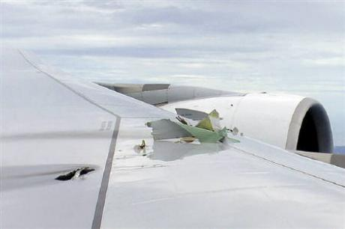
Qantas has been in the news in the past few days for all the wrong reasons. First an engine on one of their new A380s, with nearly 500 people on board, exploded shortly after take-off from Singapore, damaging the wing and showering large chunks of debris onto an Indonesian village below. It managed to return to Singapore where it made an emergency landing. (See pics). Then the next day, a 747 which had been sent to Singapore to evacuate the people had an almost identical problem! And at about the same time, a Qantas flight from HK to London had hydraulic problems but landed safely in London. Quantas aircraft have been involved in a number of serious incidents in recent years. People suspect that it is due to cost-cutting and outsourcing of maintenance to other countries instead of doing it in Australia as in the past. And to make it worse, they are celebrating their 90th anniversary. Taking part in the festivities is John Travolta, who is a qualified pilot and who flew his own Boeing 707, which was formerly operated by Qantas, to Sydney.
As a result of the US printing money and so devaluating its currency, the value of other currencies is rising. In NZ, this led to Warner Brothers almost cancelling the production of its movies about the Hobbits and moving it to a country where production costs are lower. They reneged after the NZ government offered to give the company a subsidy. Apparently, the Lord of the Rings movies is a big tourist attraction for the country.
There were a series of Rugby tests yesterday in the Northern hemisphere. The ABs beat England 26-16, SA beat Ireland 25-16 and Australis beat Wales 25-18.
I mentioned (I think) that I have been reproducing my website pages by constructing them from scratch using HTML language. I have nearly finished though there are certain features that I do not know about to be able to reproduce. It is a useful exercise actually trying to copy other pages exactly rather than just preparing your own page as you are forced to pay attention to many small details that you would not worry about if it was not a copy. My copy works perfectly on the Google Chrome browser. On IE, most of it works, though IE does not like anything that has to do with Google files! But in Firefox, which is supposed to be a good browser, it is a disaster; my pages only partly open, are all messed up and when you click on links, nothing works. I thought it may have been because I had an older version on Firefox so I uninstalled that and installed the latest version but the problem persists.
That’s about it for now.
Cheers

